Effects of Sound on the Marine Environment

Quick Start Guide

19 December 2012

# RELEASE NOTES

This version is the first full release for ESME Workbench 2012. The following caveats and warnings are given:

1. The database schema used to store, retrieve, and manage data in ESME is in flux, and subject to change. There is **no guarantee** that user data generated by this version of ESME will be compatible with future application updates. In order to update from this version, it is possible that previous experimental data will be **permanently lost**.
2. If you have installed ESME 2012 Beta 1 or Beta 2, installation of ESME 2012 will **permanently remove** any previous databases of acoustic data and scenarios.

# Introduction

ESME is an ONR Life Sciences Research Program focused on producing an integrated computer model of animal response to the sound fields produced by human activities, with a special emphasis on naval sound sources such as sonars, explosives, and acoustic communications.

This is the first full release of the ESME Workbench 2012. It allows you to create, edit, and explore ocean environments across the globe and visualize and analyze the transmission of sound underwater with two different sound propagation algorithms. Narrowband sound sources can be created, positioned, and moved, and their sound propagation fields are then used to simulate the effect of manmade noise on model marine mammals that are in range. Exposure histograms are generated for each species, and the simulation log file is provided, along with a software API, so that further custom analysis may be performed.

## Installation

ESME Workbench can be installed by downloading the latest version from <http://esme.bu.edu/download> . The installer will install the Workbench and a default set of environmental databases. Installed size is approximately 1.8GB.

## Getting Started

Having successfully installed the ESME Workbench and all associated Environmental Databases, navigate to the ESME Workbench icon in the Start Menu, and launch ESME.

The first time ESME runs, a wizard will run to help you configure some default locations. Select “Yes”. A progress window will display over the main UI:

|  |  |
| --- | --- |
|  |  |

This will create three sample locations, each with one high frequency acoustic source, one low frequency source, one sample mammal population, and four types of environmental data, at various interesting locations along the coastal United States. Each of these locations, in turn, contains sound propagations to visualize.

Once up and running, more locations, scenarios, and sound sources can be created and interacted with.

# A Brief Example

The configuration wizard has created a collection of pre-computed examples for browsing and exploration. To get a feel for how ESME works, let’s open a location and its associated scenario, and then visualize the sound propagation at a particular location in that part of the ocean.

#### Opening a Location

|  |  |
| --- | --- |
|  | First, locate the Southern California item in the Locations pane located on the lower left hand side of the application window. Right-click on “Southern California” and select “Zoom to Location”. This will re-center the map display to the southern coast, and zoom in to the boundary of the location. The checkbox next to each location toggles the display of its boundary on the map. |

#### Opening a Scenario

|  |  |
| --- | --- |
|  | Expand the Southern California tree by clicking on the arrow expander on the left side of its name. Expand Scenarios, select “Southern California Sample”, right click, and select “Open this Scenario”. The Scenario sidebar, located above the Location sidebar, will populate with items. |

#### Viewing Environmental Data

|  |  |
| --- | --- |
|  | Next, inside the Scenario sidebar, expand the Environment tree. Check the environmental data type to be visualized on the map, and it will display. Mouse over the map itself and look in the tray on the bottom of ESMEs window to see detailed information about each environmental data type.  Double click on the map to see a graph of the sound speed profile at that point of the ocean. |

|  |  |
| --- | --- |
|  | The map display will update with the visualized environmental data. Here, bathymetry is shown. Wind speed, the location of each sound speed point, and bottom sediment type are all also available. |

#### Viewing a transmission loss

|  |  |
| --- | --- |
|  | In the Scenario sidebar, expand the Analysis Points tree, and double-click on the analysis point inside. The transmission loss viewer will appear. |

|  |  |
| --- | --- |
|  | Using the slider near the bottom of the transmission loss viewer, scroll through each directional slices in the analysis point. Click and drag on the color bar to adjust the displayed scale.  From here, the displayed transmission loss radial can be saved to disc as an image or CSV file. |

|  |  |
| --- | --- |
|  | By default, the color bar scale is relative to the minimum and maximum value of the *entire* transmission loss at that analysis point.  Double-click to reset the scale to be relative to the *current* radial of that transmission loss’ values. |

#### Viewing Marine Mammal Populations

|  |  |
| --- | --- |
| The configuration wizard has added an example marine mammal population to each scenario. In the Scenario tab, expand the Species tree, and check the species to display it on the map. | ESME uses the Marine Mammal Movement and Behavior (3MB) program for the creation and simulation of animal movement and behavior within the ocean. The program permits a bounded stochastic simulation of individual animals, or animats, through defined behavioral states.  For this version of ESME, animals are seeded throughout the simulation area with a uniform, user-specified population density specified in average number of animals per square kilometer. The default value is 0.01.  Species can be repopulated, or their properties changed, via a context menu.  Each species has predefined behaviors and modeling constraints that 3MB uses for animal movement, placement, diving profile behavior, podding behavior, and more.  Twenty-one marine mammal species are currently supported. |
|  |
|  |

#### Simulating Marine Mammal Sound Exposure

With the calculated transmission losses of at least one acoustic source in at least one location and at least one species population of marine mammals, the effect of that source on that species can be modeled for a given period of time at a given time resolution. With this information, preliminary summary statistics can be calculated and plotted and the data exposed for further analysis via MATLAB.

Pressing the Run Simulation button on the ribbon control launches the Scenario Simulator dialog window.

|  |  |
| --- | --- |
|  | The default time step length is equal to the longest active time of any acoustic source in the scenario, but can be changed as desired.  If Animate Display is checked, the map display will animate as the simulation runs. The currently active sound sources will display on the map and update their position and bearing at every time step. In certain cases, this will result in the displayed modes flickering rapidly as they turn on and off according to their duty cycles.  If “Simulate animal movement” is checked, 3MB will, at each time step, update the position of each animat in the scenario according to its respective movement model. **Note: this will greatly increase the time each scenario takes to complete.**  Once the simulation is complete, a directory will be created in the My Documents folder named ESME Simulations. Inside this directory, one directory will be created for each Scenario and uniquely time-stamped simulation run.  If the “Display exposure histograms” button is checked, after the simulation completes, summary graphics will be displayed.  Each histogram shows the relative effect of each distinct mode in the simulation on a given species, binned over the range of 100-200 dB SPL in 10 dB bins. |
|  |
|  |
|  |

#### Analysis of previously-run simulations

The ESME simulator logs exposures for every animat, every distinct mode, and every time step. For complicated scenarios with many species and many platforms over long durations, it will be desirable to restrict different criteria and generate focused exposure histograms.

The Simulation Log Analysis tool is included in the program directory in which ESME is installed. Launching it displays the following interface, independent of the Workbench:

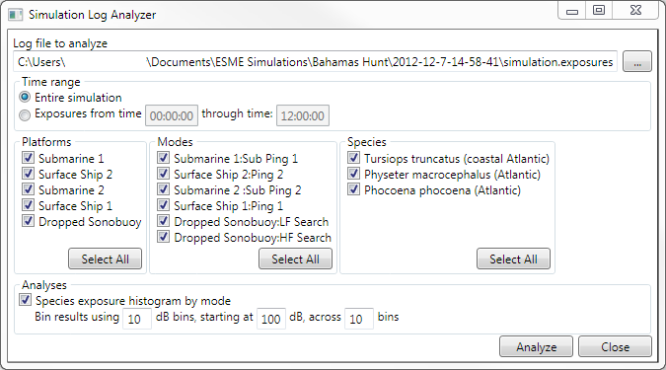

By default , simulations are stored as a simulation.exposures log file in an automatically generated tree in the “My Documents” folder. When a given exposures file is loaded, it can be re-analyzed by selectively choosing:

* Which time period to examine
* Which platforms to include or exclude from analysis
* Which modes to include or exclude from analysis
* Which species to include or exclude
* The exposure histogram bin widths and frequency range.

This brief tour should introduce many interesting concepts and means of interaction with preexisting data.

In the remainder of this Quick Start Guide, the user interface and the data it controls will be discussed in greater detail.

# ESME Workbench in More Depth

A few concepts are fundamental to ESME.

* A **Location** is an area of the ocean that has a specified **Bounding Box** and a **Name**.
* A **Scenario** is set in a **Location** during a **Time Period.**  It is a collection of one or more acoustic **Modes** of an acoustic **Source** that is associated with a **Platform**, as well as **Environmental Data** at a specific data **Resolution** associated with that Location and Time Period.
* An **Analysis Point** is a collection of the calculated sound propagation data for one or more modes. These are collectively called **Transmission Losses**, and model the complex interaction between an acoustic source and its underwater environment.

Once one or more modes are present, the transmission losses are calculated with Bellhop, a highly efficient acoustic ray-tracer provided by HLS Research.

## The Main Graphical User Interface

Similarly to many common GIS and mapping applications, interaction with ESME is mostly accomplished by interacting directly with the map itself, or by interacting with the tree control on the left-hand side of the window. This is further divided into two main panes: the **Location Pane** and the **Scenario Pane**.

### The Location Pane

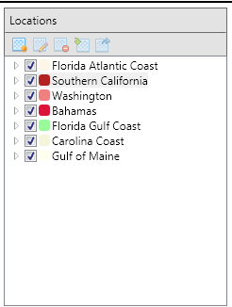 The Location Pane displays the currently configured Locations, and provides the primary way to:

* Create a new location
* Delete a selected location
* Edit the properties of a location

The buttons at the top of the pane all have tooltips that explain their respective functions.

Each location has a checkbox, which toggles the display of its bounding box on the world map. Clicking on the colored rectangle next to each location name lets the color and weight of the bounding box be customized.

Right clicking on the location name lets you zoom the world map to the bounds of that location, as well as other interactions.

Drilling down into each location exposes a hierarchy of data associated with that location:

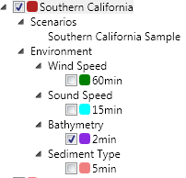

* The Environmental Data associated with the Location are shown. Each layer can be visualized separately on the map by clicking its checkbox.
* Each Location can be selected, viewed, or deleted through a context menu.
* The Scenarios that are associated with the Location are shown. Right clicking on one allows it to be loaded or modified. The scenario creator can be accessed through this context menu, preconfigured with the selected Location.

### The Scenario Pane

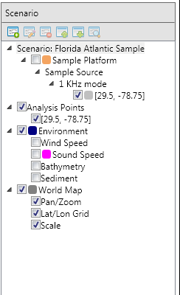The Scenario Pane displays all relevant information about acoustic sources operating in a particular Location, and is the primary way to:

* Create new scenarios
  + Top buttons or context menu on the Scenario tree
* Add, remove, or modify acoustic emitters
  + Context menus on Scenarios, Platforms, Sources, Modes.
  + F2 or double-click to rename
  + Select Properties dialog to modify acoustic parameters.
* Modify or delete previously calculated transmission losses
  + Context menu delete function
* Draw or hide visualizable data on the map
* Context menus on drawable items allow layer order to be moved
  + Checkboxes next to drawable items toggle display status
* View, save, and interact with transmission loss raytraces

### The Map

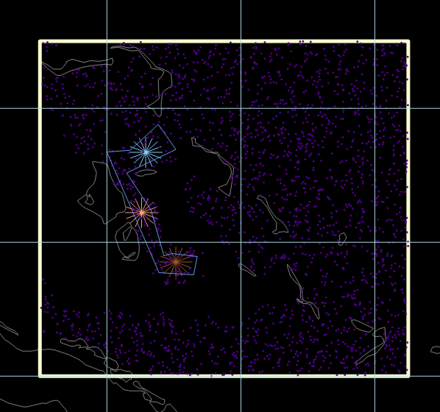

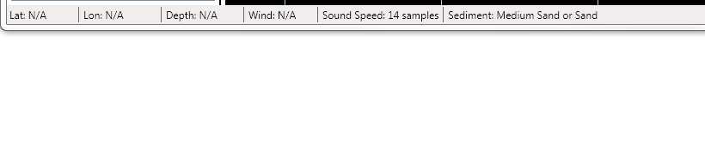

The Map displays currently selected geographic areas and environmental and experimental data. Here, three analysis points inside a containing perimeter are shown in the Bahamas with a seeded population of marine mammals also displayed. Environmental data is currently hidden. A status bar at the bottom of the application window shows detailed information for each data point, and updates as the cursor is moved.

For latitudes and longitudes that have data, the depth is displayed in meters, the wind speed in meters per second, the resolution of the sound speed calculation at that location, and the type of sediment at that location.

### Manipulation of Data Layers

#### Layer Display Order

When displaying multiple data layers at once – for example, both a collection of analysis points and bathymetric data – it is usually necessary to re-arrange the order in which these layers are displayed, as they are all completely opaque and will obscure layers shown under them.

|  |  |
| --- | --- |
|  | A series of options are available in the context menu of any visualizable item in the Scenario or Locations panel to accomplish this. Items can be moved forward or back in the display order, as well as displayed on top of everything, or sent to the very bottom. |

#### Layer Color

|  |  |
| --- | --- |
|  | Items listed in the tree control with a colored rectangle next to them can have different displayed colors and line weights. Currently Modes, the World Map, the Environment bounding box, and Platforms can all have custom colors.  Colors are randomly assigned for each layer type on creation, but can be freely adjusted.  To change the color of the layer in question, drill down in the selected Scenario or Location to the layer in question, and left-click on the colored square next to its name. A color selector dialog will let you adjust the color and the line weight.  These changes will persist and reappear the next time the Scenario is loaded. |
|  |

#### Sound Speed Visualization

The speed of sound in salt water varies as a function of salinity, temperature, and pressure. *Double-clicking on the map* anywhere within the Location boundaries displays the sound speed profile at that location, calculated using the most appropriate environmental data.

|  |  |
| --- | --- |
|  | The sound speed display window updates when a new location on the map is double-clicked.  The sound speed profile can be either copied to the clipboard or saved as an image or CSV file. |

# Location Interaction

Locations drive the rest of ESME. Without them, no scenarios may be created, no transmission losses calculated, and no other actions taken.

## Location Creation

To start creating a location, select the “New Location” button on the Location Pane

|  |  |
| --- | --- |
|  | This will launch the location creation tool, which is a combination of a map interaction element and a dialog box.  The map element is a large blue rectangle, which can be positioned anywhere on the map.  The dialog box is a simple selector displaying the four corners of the selected area and a name. |

|  |  |
| --- | --- |
|  | In this example, a location that encompasses approximately half of Cuba, all of Haiti and the Dominican Republic, the Bahamas, Jamaica, Puerto Rico, and assorted other Caribbean islands is selected. Once a name has been entered into the creation dialog box, the OK button becomes clickable, and this area will be added to the database of currently defined Locations. |

|  |  |
| --- | --- |
|  | That’s it! The location is added to the database, and appears in the Locations Panel in the main application window. |

## Scenario Creation

To start creating a Scenario, either click the “New Scenario” button in the Scenario Pane, or select “New Scenario” from the context menu of the Location in the Location Pane that you wish to use.

|  |  |
| --- | --- |
|  | If the scenario creator is launched from the scenario pane, a scenario may be created in any current Location.  If the scenario creator is launched from a Location’s context menu, it will be created in that location. |
|  |

Next, the Create Scenario dialog will open.

|  |  |
| --- | --- |
|  | Enter a Scenario Name, and some optional comments.  Select a time period in which the scenario takes place.  Select a duration of time for which the scenario will proceed.  Certain types of environmental data and animal population data are time dependent.  Select the source and resolution of the environmental data available to you. In this example, wind and sound speed data exist at only one resolution, so no option is given. Sediment and bathymetry, however, have multiple resolutions. Higher resolutions will require slightly more time to be made available.  Currently, two environmental data plugin types are available.   1. ESME Workbench (default)   Pre-extracted environmental data from the Ocean Acoustics Master Library. Fast extraction.   1. NAVO   An explicit interface to the OAML data if the user has the original data previously. |
|  | The newly created scenario appears in the Scenario Pane, and can be interacted with as usual. |

## Adding Platforms, Sources, and Modes

A **Platform** is any object that carries acoustic sources and can change position in the ocean. A **Source** is a particular type of sound emitter mounted on a platform. A **Mode** is a particular combination of propagation parameters that define one way in which a Source may function.

For example, the recently decommissioned attack submarine Platform USS Los Angeles carried multiple Sources. One such source was a BBQ-5 type spherical array active/passive SONAR array, which operated in one of several search Modes. These, in turn, have several properties that are used to calculate its Transmission Loss in a given area.

To place this platform in the Scenario:

|  |  |
| --- | --- |
|  | Right-click on the scenario name, and select “Add Platform” from the context menu.  Enter “USS Los Angeles” as the Platform name, and press Enter to confirm.  Right-click on the newly-created platform, and add a Source named BBQ-5 in a similar manner.  Continue on to add a mode named Search, and then edit its properties. |
|  |
|  |

|  |  |
| --- | --- |
|  | Mode type is text that identifies the mode to the user.  A depth offset of 10 meters means the emitter is 10 meters under water.  The source level is the loudness of the sound 0 meters from the emitter.  The vertical beam width is the width, in degrees, that the emitter subtends as it propagates. A value of 360 means the source is omnidirectional.  The depression/elevation angle is the direction the source is pointed in. 0 degrees is horizontal propagation, 90 degrees is pointed directly at the bottom, -90 is pointed at the surface.  The pulse length and interval specify the duty cycle of the specified acoustic behavior. |

## Adding Species

|  |  |
| --- | --- |
|  | ESME uses the Marine Mammal Movement and Behavior (3MB) program for the creation and simulation of animal movement and behavior within the ocean. The program permits a bounded stochastic simulation of individual animals, or animats, through defined behavioral states.  Simulated animals, or animats, are represented with a dot on the screen at their current latitude and longitude. |

When an animal population is added, 3MB is queried to determine the initial starting positions of each animal. If a simulation is run with moving animals, they will change position and depth according to their species type at each time step.

## Analysis Points and Transmission Loss Calculation

An **Analysis Point** is a collection of the transmission losses of all unique modes, propagated from a specific latitude and longitude, which are defined in the loaded scenario when that analysis point is placed. As sound sources move during simulation, their acoustic behavior will be modeled using the transmission losses from the nearest analysis point at each time step.

|  |  |
| --- | --- |
|  | To add an Analysis Point to the Scenario, click on the Analysis Point button in the ribbon. The cursor will change to a large cross when it is inside the Location and a red “Not-Allowed” symbol when it is outside. Press Escape to exit the analysis-point placement state if you have entered it in error or no longer wish to place one; otherwise, click anywhere inside the location and an analysis point will be placed. |

Once an analysis point is placed, the transmission losses will automatically be queued and calculated. The remaining number of calculations is displayed in the lower right-hand corner of ESME’s status bar.

## Transmission Loss Calculators

ESME has two algorithms for sound propagation modeling.

### Bellhop

Bellhop is a highly effcient ray tracing program, written in Fortran by Michael Porter as part of the Acoustic Toolbox. Bellhop is designed in order to perform two-dimensional acoustic ray tracing for a given sound speed profile or a given sound speed field in ocean waveguides with flat or variable absorbing boundaries. Output options include ray coordinates, travel time, amplitude, eigenrays, acoustic pressure, or transmission loss (coherent, incoherent or semi-coherent). [HLS Research,2008]

### RAM

RAM is a fully range dependent parabolic equation solver using a 6th order split-step Pade approximation of the PE solution with a Chebyshev smoothing window for modeling range-dependent wave propagation in the ocean. It was developed by Michael Collins at the Naval Research Laboratory, and its inclusion provides ESME with reliable low-frequency propagation modeling capabilities.

# Transmission Loss Visualization

Transmission losses are fundamental to ESME.

Visualization of TLs happens at three levels of detail:

1. *The Transmission Loss Viewer stand-alone application.*

This application is launched from the windows Start Menu, and displays all calculated TLs stored on disk from every location and scenario.

1. *The analysis point viewer*

Double-clicking on a loaded scenario’s analysis point launches the analysis point viewer. All transmission losses calculated at that point are displayed.

1. *The mode transmission loss viewer*

The transmission loss of a particular acoustic mode at a particular location is shown.

### The Transmission Loss Viewer

All ways of viewing a transmission loss result in the same fundamental display: 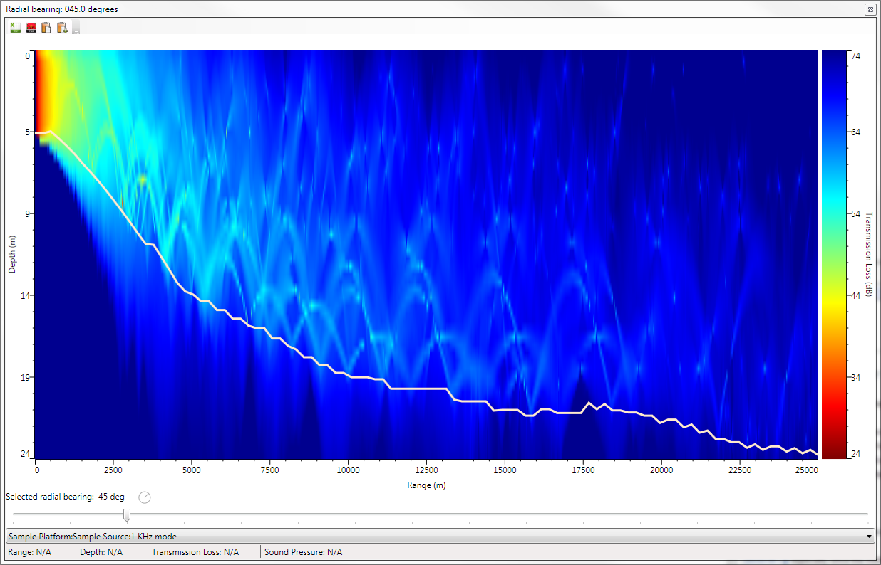

A sound sources’ transmission loss is calculated as one two-dimensional plane every 22.5 degrees rotating about the latitude and longitude of the analysis point. In the plot above, the white line represents the bathymetric profile along that radian: any point below the line is sediment. Any point above it is water. The acoustic reflectivity of the water at the surface is an indirect function of the wind speed at that location. Sound transmission into sediment is similarly a consequence of different sediment types’ ability to absorb or reflect sound.

Moving the mouse inside the plotted radial will update the status bar at the bottom of the window to display the current range from the source, depth in the water column, and what the transmission loss and sound pressure level are at that location, if there are any available. With certain sources, it is possible for no sound wave to pass through a given location of simulated ocean; in this case, the display will register N/A.

The color bar on the right hand side of the window is fully interactive. By default, its bounds are set to the global minimum and maximum of all radials in the selected mode’s transmission loss. However, double-clicking on the color bar will switch to the local minimum and maximum values of the selected radial. In this way, the relative loudness of the source at a given position may be more easily conceived. In addition, the color bar range may be manually adjusted by clicking and dragging to expose the fine structure of each radial, if desired.

The color bar will dynamically adjust to the global minimum and maximum of the *currently calculated* radials. If an analysis point or TL is visualized before all radials have completed calculation, the color bar will readjust as new radials finish calculation.

A toolbar at the top of the control allows the displayed transmission loss to be saved either to CSV or an image file, as well as copied to the clipboard.

If an analysis point is being displayed, a drop-down menu will be at the bottom of the control, from which may be selected all available modes for that analysis point.

If a transmission loss is displayed, the menu will be hidden.

If the external Transmission Loss Viewer is launched from the windows Start Menu, a tree view of all scenarios and locations stored on disc will be presented instead.

## Simulations

A **Simulation** is the systematic exposure of sound sources to marine mammal populations. In order for a simulation to run, the following elements must be defined in the Scenario:

1. A Scenario with a defined duration.
2. At least one fully-defined Acoustic Mode. This implies that there must also be at least one fully specified Platform and Source, with optional bounding perimeter and movement model.
3. At least one Analysis Point with fully calculated transmission losses.
4. At least one defined population of marine mammals.

Once these criteria are met, a simulation can be run at a specified time resolution.

At each time step, the simulator:

1. Moves all non-stationary acoustic sources.
2. Determines, from their defined properties, which acoustic modes are active.
3. If the display is being animated, redraws the new source position and the effective coverage area of each active mode.
4. If the simulation involves moving animals, query 3MB for updated positions and then move and display the animat position.
5. For each animal that is currently within the effective radius of each platform, determine the effective sound pressure level and energy exposure from each active mode it is being exposed to.
6. Log this data into a simulation file.
7. Passes exposure information to all available and relevant summary statistics plugins, which accumulate data for reporting and graphical representation of the effect of the acoustic sources on the marine populations in the simulation.

# Conclusion

This concludes the ESME Workbench 2012 Demo Quick Start Guide.

More new features scheduled for inclusion:

* Addition of new environmental databases
* Addition of RAM, an acoustic simulator for low-frequency sources.